SEC Form 3
FORM 3 | UNITED STATES SECURITIES AND EXCHANGE COMMISSION  Washington, D.C. 20549  INITIAL STATEMENT OF BENEFICIAL OWNERSHIP OF SECURITIES  Filed pursuant to Section 16(a) of the Securities Exchange Act of 1934  or Section 30(h) of the Investment Company Act of 1940
  OMB APPROVAL
  OMB Number: | 3235-0104
  Estimated average burden
  hours per response: | 0.5
1. Name and Address of Reporting Person*  (Street) | 2. Date of Event Requiring Statement (Month/Day/Year)  10/12/2026 | 3. Issuer Name and Ticker or Trading Symbol  AMERICAN INTERNATIONAL GROUP, INC. [ AIG ]  Foreign Trading Symbol
  Hussain Mohammad
  (Last) | (First) | (Middle)
  C/O AMERICAN INTERNATIONAL GROUP, INC.
  1271 AVENUE OF THE AMERICAS
  NEW YORK | NY | 10020
  (City) | (State) | (Zip)
 |  | 4. Relationship of Reporting Person(s) to Issuer  (Check all applicable) | 5. If Amendment, Date of Original Filed (Month/Day/Year)
   | Director |  | 10% Owner
   | Officer (give title below) |  | Other (specify below)
  EVP, Chief Risk Officer
6. Individual or Joint/Group Filing (Check Applicable Line)
Form filed by One Reporting Person
Form filed by More than One Reporting Person

Table I - Non-Derivative Securities Beneficially Owned
1. Title of Security (Instr. 4) | 2. Amount of Securities Beneficially Owned (Instr. 4) | 3. Ownership Form: Direct (D) or Indirect (I) (Instr. 5) | 4. Nature of Indirect Beneficial Ownership (Instr. 5)
Common Stock | 37,372(1) | D
Table II - Derivative Securities Beneficially Owned
(e.g., puts, calls, warrants, options, convertible securities)
1. Title of Derivative Security (Instr. 4) | 2. Date Exercisable and Expiration Date (Month/Day/Year) |  | 3. Title and Amount of Securities Underlying Derivative Security (Instr. 4) |  | 4. Conversion or Exercise Price of Derivative Security | 5. Ownership Form: Direct (D) or Indirect (I) (Instr. 5) | 6. Nature of Indirect Beneficial Ownership (Instr. 5)
1. Title of Derivative Security (Instr. 4) | Date Exercisable | Expiration Date | Title | Amount or Number of Shares | 4. Conversion or Exercise Price of Derivative Security | 5. Ownership Form: Direct (D) or Indirect (I) (Instr. 5) | 6. Nature of Indirect Beneficial Ownership (Instr. 5)
2022 Stock Options (Right to Buy) | 02/22/2025 | 02/22/2032 | Common Stock | 9,118 | 61.61 | D
2023 Stock Options (Right to Buy) | 02/21/2026 | 02/21/2033 | Common Stock | 9,960 | 59.72 | D
2024 Stock Options (Right to Buy) | (2) | 02/20/2034 | Common Stock | 12,115 | 68.13 | D
2025 Stock Options (Right to Buy) | (3) | 02/18/2035 | Common Stock | 12,768 | 75.46 | D
2026 Stock Options (Right to Buy) | (4) | 02/17/2036 | Common Stock | 11,742 | 79.4 | D
Explanation of Responses:
1. Includes 21,920 shares of common stock; 6,486 shares underlying the 2026 Restricted Stock Units ("RSUs") granted on February 17, 2026 which will vest in equal amounts on each of the first, second and third anniversaries of the grant date; 4,402 shares underlying the 2025 RSUs granted on February 18, 2025 which will vest in equal amounts on each of the second and third anniversaries of the grant date; 2,028 shares underlying the 2024 RSUs granted on February 20, 2024 which will vest on the third anniversary of the grant date; and 2,536 shares underlying the 2023 RSUs granted on December 15, 2023 which will vest on the third anniversary of the grant date. Vesting of all RSUs are contingent on the reporting person's continued employment through each applicable vesting date and each RSU represents a contingent right to receive one share of AIG common stock upon vesting.
2. Represents the 2024 Stock Options granted on February 20, 2024. One third of the 2024 Stock Options vested on each of the first and second anniversaries of the grant date, and the remaining stock options will vest on the third anniversary of the grant date, subject to the reporting person's continued employment through the applicable vesting date.
3. Represents the 2025 Stock Options granted on February 18, 2025. One third of the 2025 Stock Options vested on the first anniversary of the grant date, and the remaining stock options will vest in equal amounts on each of the second and third anniversaries of the grant date, subject to the reporting person's continued employment through each applicable vesting date.
4. Represents the 2026 Stock Options granted on February 17, 2026. One third of the 2026 Stock Options will vest on each of the first, second and third anniversaries of the grant date, subject to the reporting person's continued employment through each applicable vesting date.
Remarks:
Exhibit 24 - Power of Attorney
 | /s/ Linda Kalayjian, by POA from Mohammad Hussain | 10/13/2026
 | ** Signature of Reporting Person | Date
Reminder: Report on a separate line for each class of securities beneficially owned directly or indirectly.
* If the form is filed by more than one reporting person, see Instruction 5 (b)(v).
** Intentional misstatements or omissions of facts constitute Federal Criminal Violations See 18 U.S.C. 1001 and 15 U.S.C. 78ff(a).
Note: File three copies of this Form, one of which must be manually signed. If space is insufficient, see Instruction 6 for procedure.
Persons who respond to the collection of information contained in this form are not required to respond unless the form displays a currently valid OMB Number.
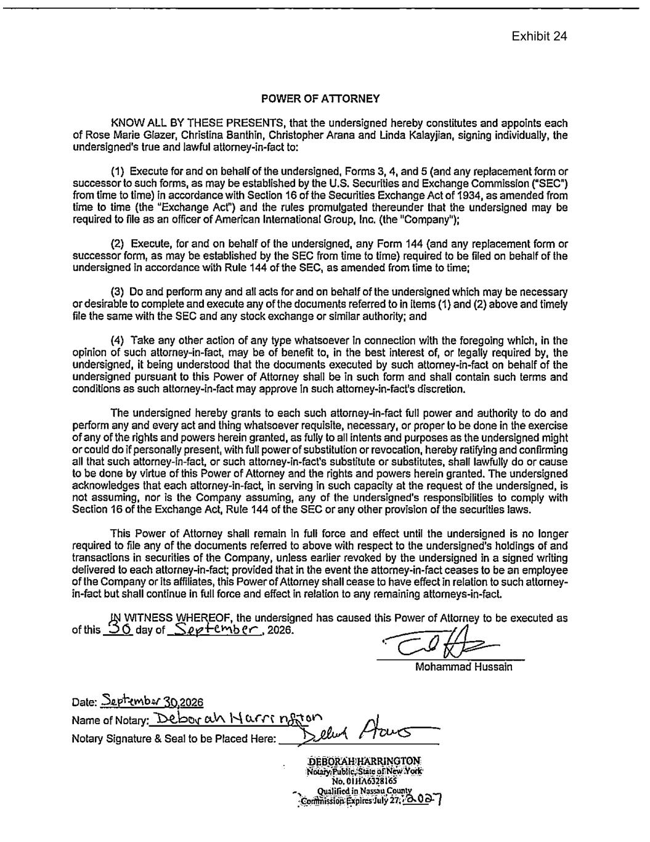
Exhibit 24

